Clara Clark Double Thick Mink Blankets
- These amazing blankets come in a variety of colours and sizes.
- You will want to order while supplies last
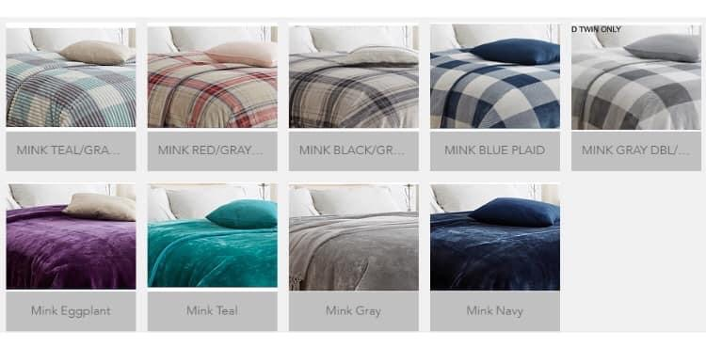
- Only $75 each with taxes included
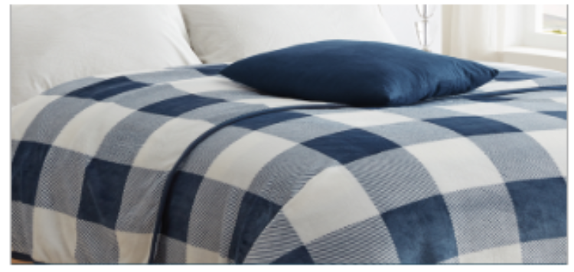
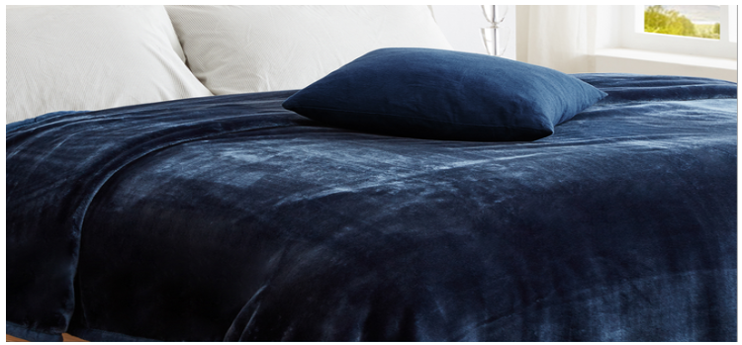

CONTACT US TODAY!!
